

Movie Database

Analysis & Design



COMP H2027 - Software Engineering & Testing

Institute of Technology Blanchardstown

2014

Lecturer: Simon McLoughlin

David Kelly: B00060572

David Malone: B00060176

**Table of contents:**

1. Project Description…………………………………………………………………… 3

2. UML Use Case Diagram……………………………………………………………... 4

3. Use Case Specifications.……………………………………………………………... 5

4. Class Description and Class Diagram………………………………………………... 9

5. Sequence Diagrams…………………………………………………………………. 10

6. User Interface Design……………………………………………………………….. 15

6.1 Search 15

6.2 Login 15

6.3 Add Movie 16

6.4 Add Review 16

6.5 Flag Content 17

6.6 Remove Content 17

6.7 Search Member 18

6.8 Create Account 18

6.9 Search Results 19

6.10 Home Item List 19

7. User Iterface………………………………………………………………………... 20

8. References……………………………………………………………...................... 20

**Project :**

The goal of this project is to develop a movie database that anyone can search through and, if an account is created, add content to. It will be primarily a desktop PC application, with the potential to be ported to mobile systems such as Android or Apples IOS. This application will be presented to the user as a neat graphical user interface with a database back end containing the content. An executable of the application will be available for download with no install required.

**Scope:**

The application will be designed for any platform that can run Java applications. It will be tested on PC, Mac OS and Linux with intent to develop for the Android and IOS mobile markets in the future. The application will not be available on the Playstation or Xbox platforms. A database will be stored in the cloud to house all of the content generated by the application users and the Java GUI front end of the application will be downloaded onto the users device to provide a client interface for database access.

**UML:**

Unified Modelng Language allowed us to create and plan our program with efficiency and relative ease. Creating a **use case diagram** first gave the team an impression of how the final system will look when completed and implemented. The **use case** helped us as a team understand the classes and methods needed for the system to interact with users, something that is integral to the systems functionality. After creating the **use case diagram** we then decided to create a **class diagram.** The **class diagram** helped us structure our classes with methods and connect the classes that need to interact with each other. In order for the system to operate as a user to database sequence with returning values displayed through the GUI, it was imperetive that we were methodical and analytical to ensure there was no unused methods and that the system was as functional and streamlined as possile. In order to confirm the methods we implemented in the **class diagram** served a purpose and were truely functional we needed to do **sequence diagrams.** The **sequence diagrams** were the final act in confirming our system had all the classes and methods needed to be operational.

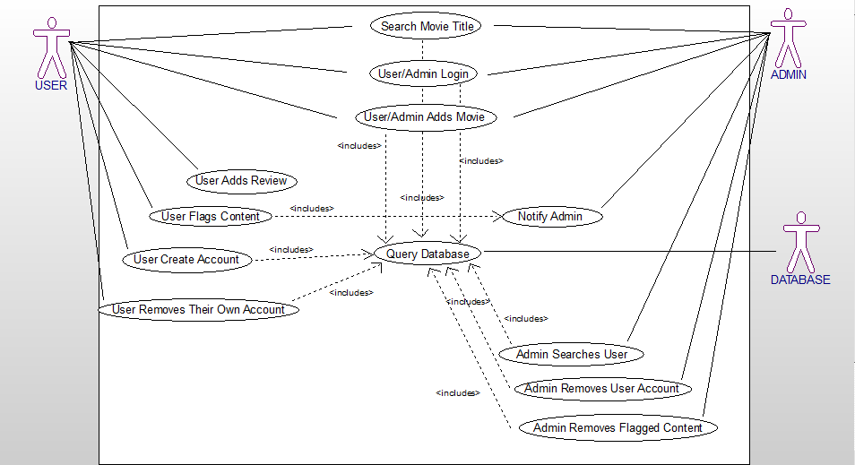

**Use case specifications:**

1. User Searches Movie Title

Primary Path

1. User input's movie title and clicks search button

2. Program queries the database

3. Program finds a matching result in the database

4. Program returns all the information under that title

5. Program displays the results

Alternative Path

3a. Program does not find the results in the database

3b. Program returns null value

3c. Program displays search fail

3d. User is returned to search bar page

2. User Creates Account

Primary Path

1.User selects create account option

2.User enters their details

3.Program verifys email format and password fields

4.Program queries the database for duplicate account details

5.Program displays successful account creation

6.Program sends an email to the users email address

7.Program logs the user in to their account

8.Program redirects the user to the home screen

Alternative Path

3a.User has entered incorrect details

3b.Program prompts the user to re enter correct details

3c.Program rechecks the details

4a.Duplicate details are found in the database

4b.Program prompts the user to change their details

4c.Program re-checks the details

3.Member/Admin Login

Primary Path

1.Member navigates to login page

2.Member enters their details

3.Program queries the database for correct details

4.Program finds the correct details and retrieves them from the database

5.Program applies the correct permissions relative to the account

6.Member is redirected to the home page

Alternative Path

3a.Program finds no matching details in the database

3b.Program shows a login failed window

3c.Program prompts the user to re-enter the correct details

3d.Program re-checks the details

4. Member/Admin Adds Movie

Primary Path

1.Member logs in

2.Member navigates to the create movie profile page

3.Member enters all the required fields on the form and clicks submit button

4.Program checks that all the required fields are entered

5.Program queries the database for a duplicate movie title

6.Program finds no duplicate movie title

7.Program adds the form information to the database

8.Member is redirected to the new movie profile page

Alternative Path

4a.Program finds the required fields have not been entered

4b.Program prompts the user to enter the required fields

4c.Program rechecks the fields

5a.Program finds a duplicate title existing in the database

5b.Program notifies the user that the title exists and shows movie information from database

5c.Program prompts the user to change their title or cancel operation

5di.Program rechecks the title 5dii.User is redirected to the create movie profile page

5.Member Adds Review

Primary Path

1.Member logs in

2.Member searches for movie

3.Member enters page of movie they wish to review

4.Member clicks on the add review button

5.Member enters their review in the text area provided

6.Member clicks the add review button when finished

7.Program adds and saves the review to the database

8.Program redirects the user to the movie title page

Alternative Path

2a.Database does not have the movie title to be reviewed

2b.Program prompts the user to add the title or cancel the search

2ci.Member adds the movie 2cii.Member is redirected to the home page

5a.Member clicks the cancel search button

5b.Program redirects the user to the movie title page

6.Member Flags Content

Primary Path

1.Member logs in

2.Member searches for content

3.Member navigates to the page containing the content they wish to flag

4.Member clicks on the flag icon related to the content

5.Program notifies user with option to confirm or cancel flagging the content

6.Member clicks confirm

7.Program sends a notification email to the admin with the content details

8.Program returns the user to the content page

Alternative Path

5a.Member cancels the flagging option

5b.Program returns the user to the content page

7.Admin Removes Flagged Content

Primary Path

1.Admin logs in

2.Admin navigates to the flagged content

3.Admin selects flagged content

4.Admin clicks the remove content button on flagged content

5.Program shows JOptionPane to confirm content removal

6.Admin clicks remove

7.Program permanently removes the content from the database

8.Program returns the admin to content page

Alternative Path

6a.Admin selects cancel option

6b.Program redirects the admin back to content page

8.Admin Searches Member

PrimaryPath

1.Admin logs in

2.Admin navigates to the search member option

3.Admin enters username in search bar and clicks search

4.Program searches the username in the database

5.Program finds the username

6.Program returns the account page for that user

Alternative Path

5a.Program does not find that username in the database

5b.Program notifies the admin that no username is found

5c.Program prompts the admin to research the username or cancel

5di.Program rechecks the database for username

5dii.Program redirects the admin back to the search username page

9.Admin Removes User Account

Primary Path

1.Admin logs in

2.Admin searches members

3.Admin clicks the remove member account button

4.Program shows a JOptionPane to confirm member removal

5.Admin clicks remove button

6.Program permanently removes the members account information from the database

7.Admin is redirected to the search member page

Alternative Path

5a.Admin selects cancel option on JOptionPane

5b.Program returns the admin to the members account page

10.Member Removes Their Own Account

Primary Path

1.Member logs in

2.Member navigates to member account page JMenuItem

3.Member clicks the remove account button

4.Member is prompted to enter their password or cancel the operation

5.Member enters their password

6.Program queries the database for matching the password

7.Program finds the matching password in the database

8.Program permanently removes the member account information from the database

9.Member is redirected to the home page search window

Alternative Path

5a.Member clicks the cancel button

5b.Program returns the member to their account page

6a.Program finds no matching password in the database

6b.Program prompts the member to re-enter their password

6c.Program rechecks the database for the password

**Classes & Attributes:**

**Account:** AccountID, Username, Password, Email

**GUI:** Input, SearchString

**System:** SearchString, ResultsString

**Movie:** MovieID, MovieName, MovieYear, MovieDescription, MovieImage

**Review:** ReviewID, ReviewName, ReviewDescription, Rating

**Database:** Movie, Review, Search, SearchResults, IsDuplicate, IsMatch, SqlQuery

**Class Diagram:**

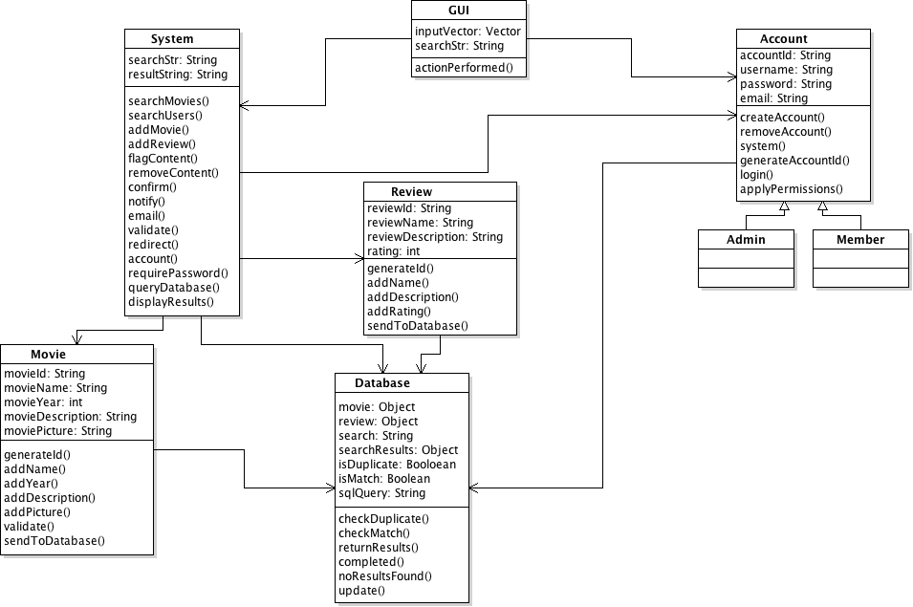

**Sequence Diagrams:**

**Search Movie:**

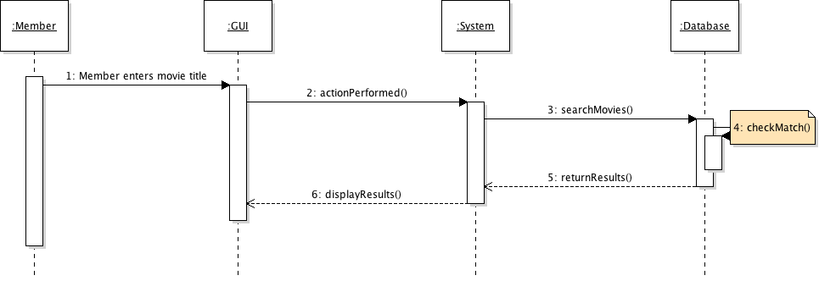

**Create Account:**

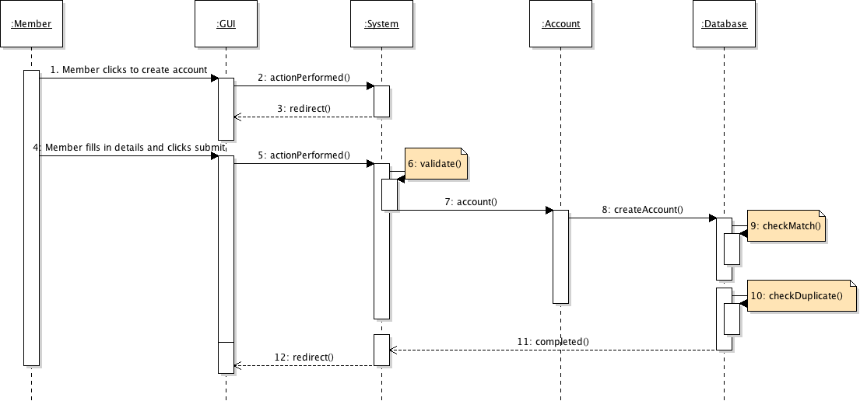

**Login:**

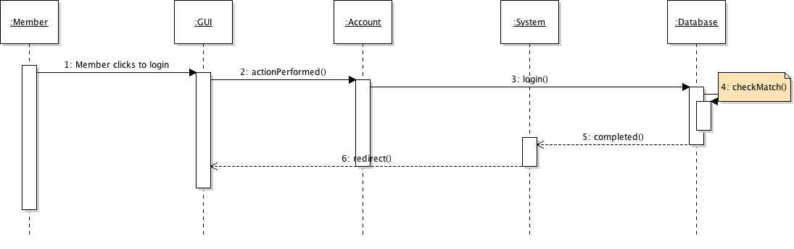

**Add Movie:**

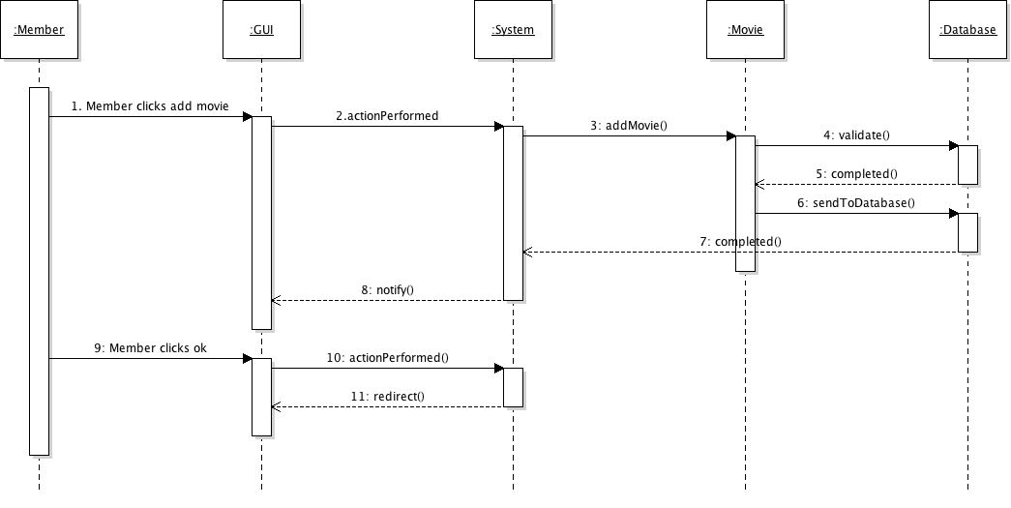

**Add Review:**

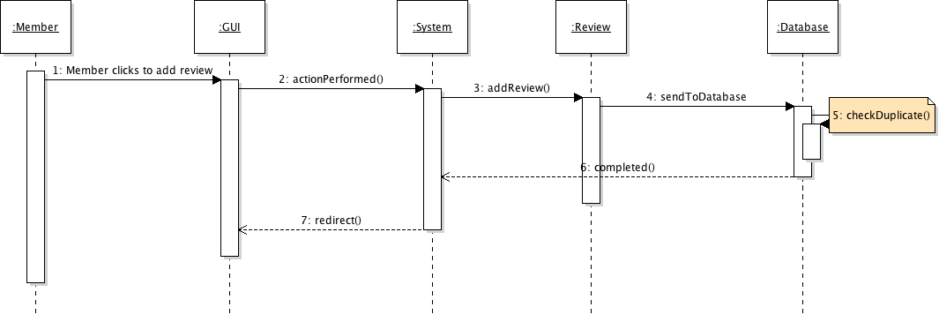

**Flag Content:**

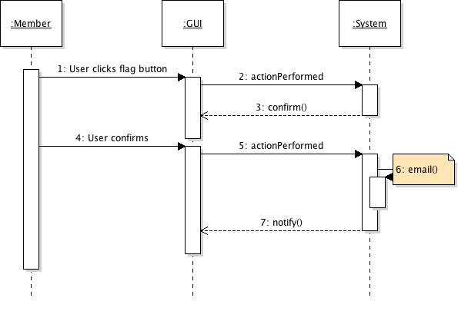

**Remove Content:**

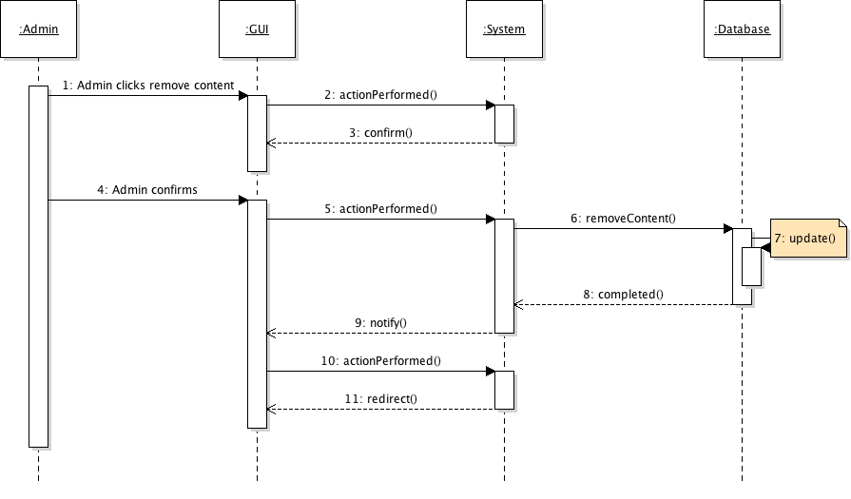

**Admin Searches Member:**

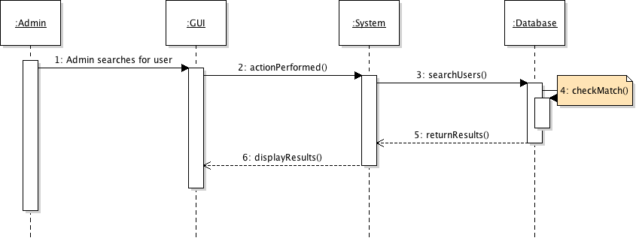

**Admin Removes User:**

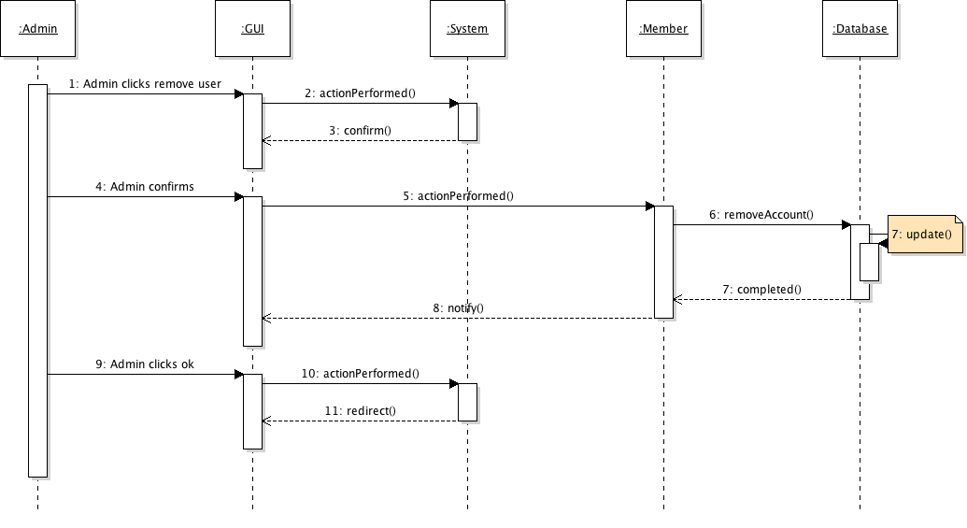

**User Removes Account:**

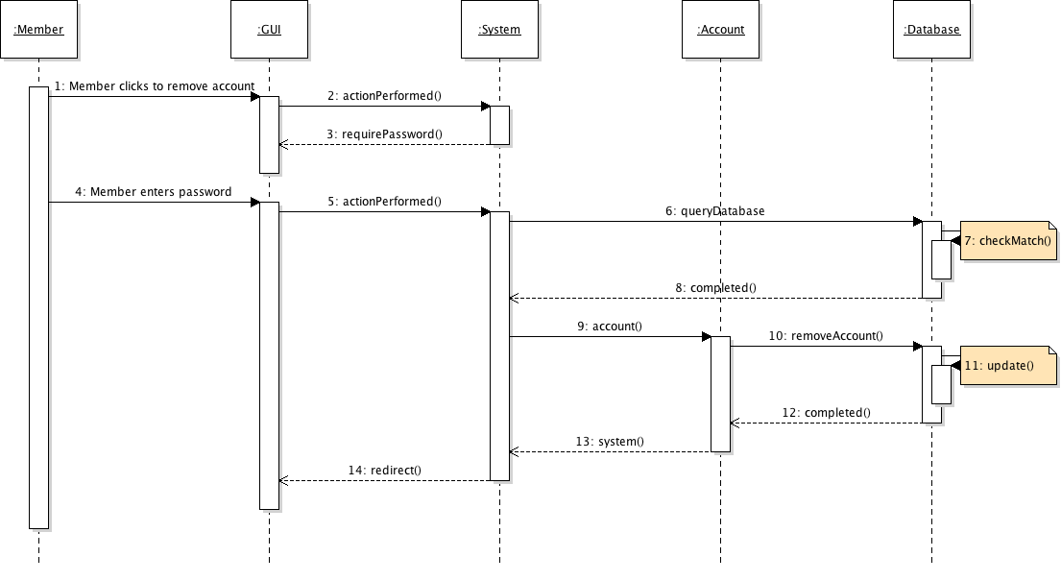

**User Interface Design**

**Home/Search:**



**Login:**

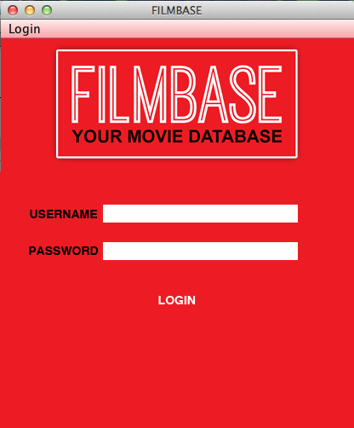

**Add Movie:**

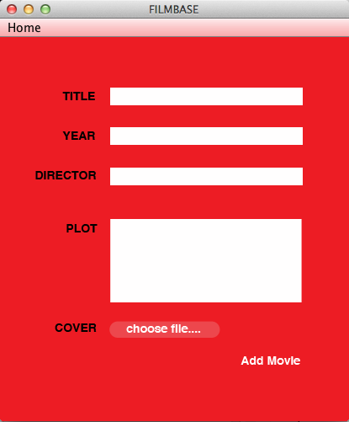

**Add Review:**

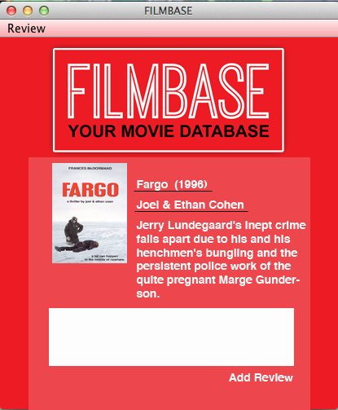

**Flag Content:**

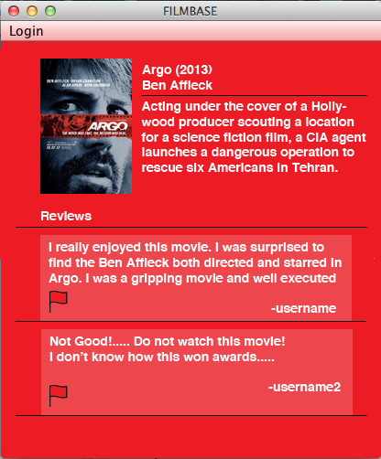

**Remove Flagged Content:**

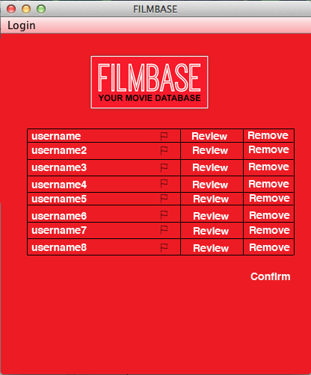

**Search Member:**

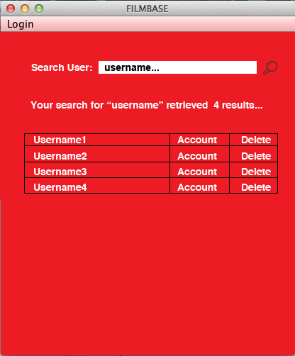

**Create Account:**

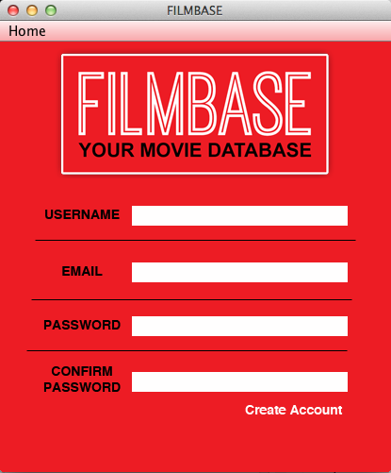

**Search Results:**



**Home Item List:**

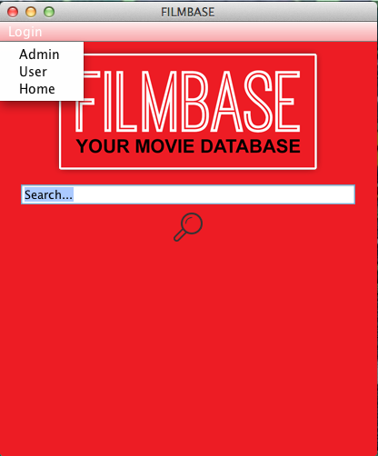

The user interface is an integral part of our system. The interface has to be consistent on all levels for the user and the administrator alike . The GUI is the link between the user and the system and must be accessible and easily navigated at all times.

We have taken the approach of seperating the GUI to it's own class and calling methods

from the system class. This modularises the code and allows methods to be used by many different classes.

The GUI we plan on implementing is very clean with only a few options for the user to interact with on any given screen. The menu option is consistent across every screen and is the users anchor for navigation. Allowing the user to access many different options from wherever they are in the system(depending on their permissions).

**References:**

Fowler, M., 2004. UML Distilled: A Brief Guide To The Standard Object Modeling

Langauge.

Pearson Education, Inc. ISBN 0-321-19368-7.

Larman, C., 2004. Applying UML and Patterns: An Introduction to Object-Oriented Analysis and Design and Iterative Development. 3rded.

Prentice Hall, ISBN 978-0131489066.